Jordan Thomas

CYBR410-T301

February 19, 2023

# Creating the whatabook database

# Creating the user for the database



Above, the users were created for localhost and for my remote host

The users are granted all permissions on the database

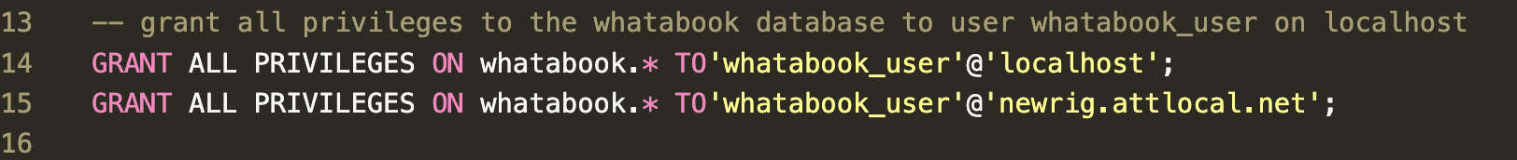

Verifying the users exist from within the MySQL prompt

# Inserting records into the database

Verifying the books were inserted with a select *

